**You have to submit this report via Moodle.**

|  |  |  |
| --- | --- | --- |
| Design of Digital Circuits: Lab Report | | |
| Lab 7: Writing Assembly Code | | |
| Date | 17.05.2021 | Grade |
| Names | Berner, Zheng |  |
|  |  | Lab session / lab room |
|  |  | Friday 08:15  Zoom breakout room 60 |

**Use a zip file or tarball that contains the report and any other required material. Only one member from each group should submit the report. All members of the group will get the same grade.**

**The name of the submitted file should be *LabN_LastName1_LastName2.zip* (or *.tar*), where *LastName1* and *LastName2* are the last names of the members of the group.**

**Note 1: Please include all the required material. No links/shortcuts are accepted.**

**Note 2: The deadline for the report is a hard deadline and it will not be extended.**

**Exercise 1**

Assume that instead of using black and white images, for which pixels are described with a single value, we use color images, i.e., every point is described by the combination of three colors (R,G,B).

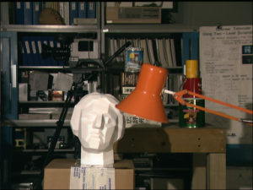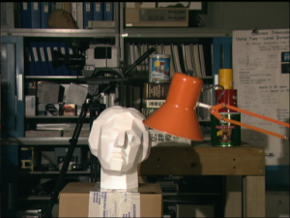

The abs_diff function can be redefined as:

int abs_diff_color(int R1, int G1, int B1, int R2, int G2, int B2) {

int abs_diff = abs(R1-R2) + abs(G1-G2) + abs(B1-B2);

return abs_diff;

}

This new function requires 6 arguments, but MIPS only provides 4 registers ($a0-$a3) to pass the arguments. How would you modify the function abs_diff() so that it adjusts to the calling convention in MIPS? You should implement the function and submit it via Moodle. Include explanations on how the function works.

**Feedback**

If you have any comments about the exercise please add them here: mistakes in the text, difficulty level of the exercise, or anything that will help us improve it for the next time.